AMADOR COUNTY ENVIRONMENTAL HEALTH
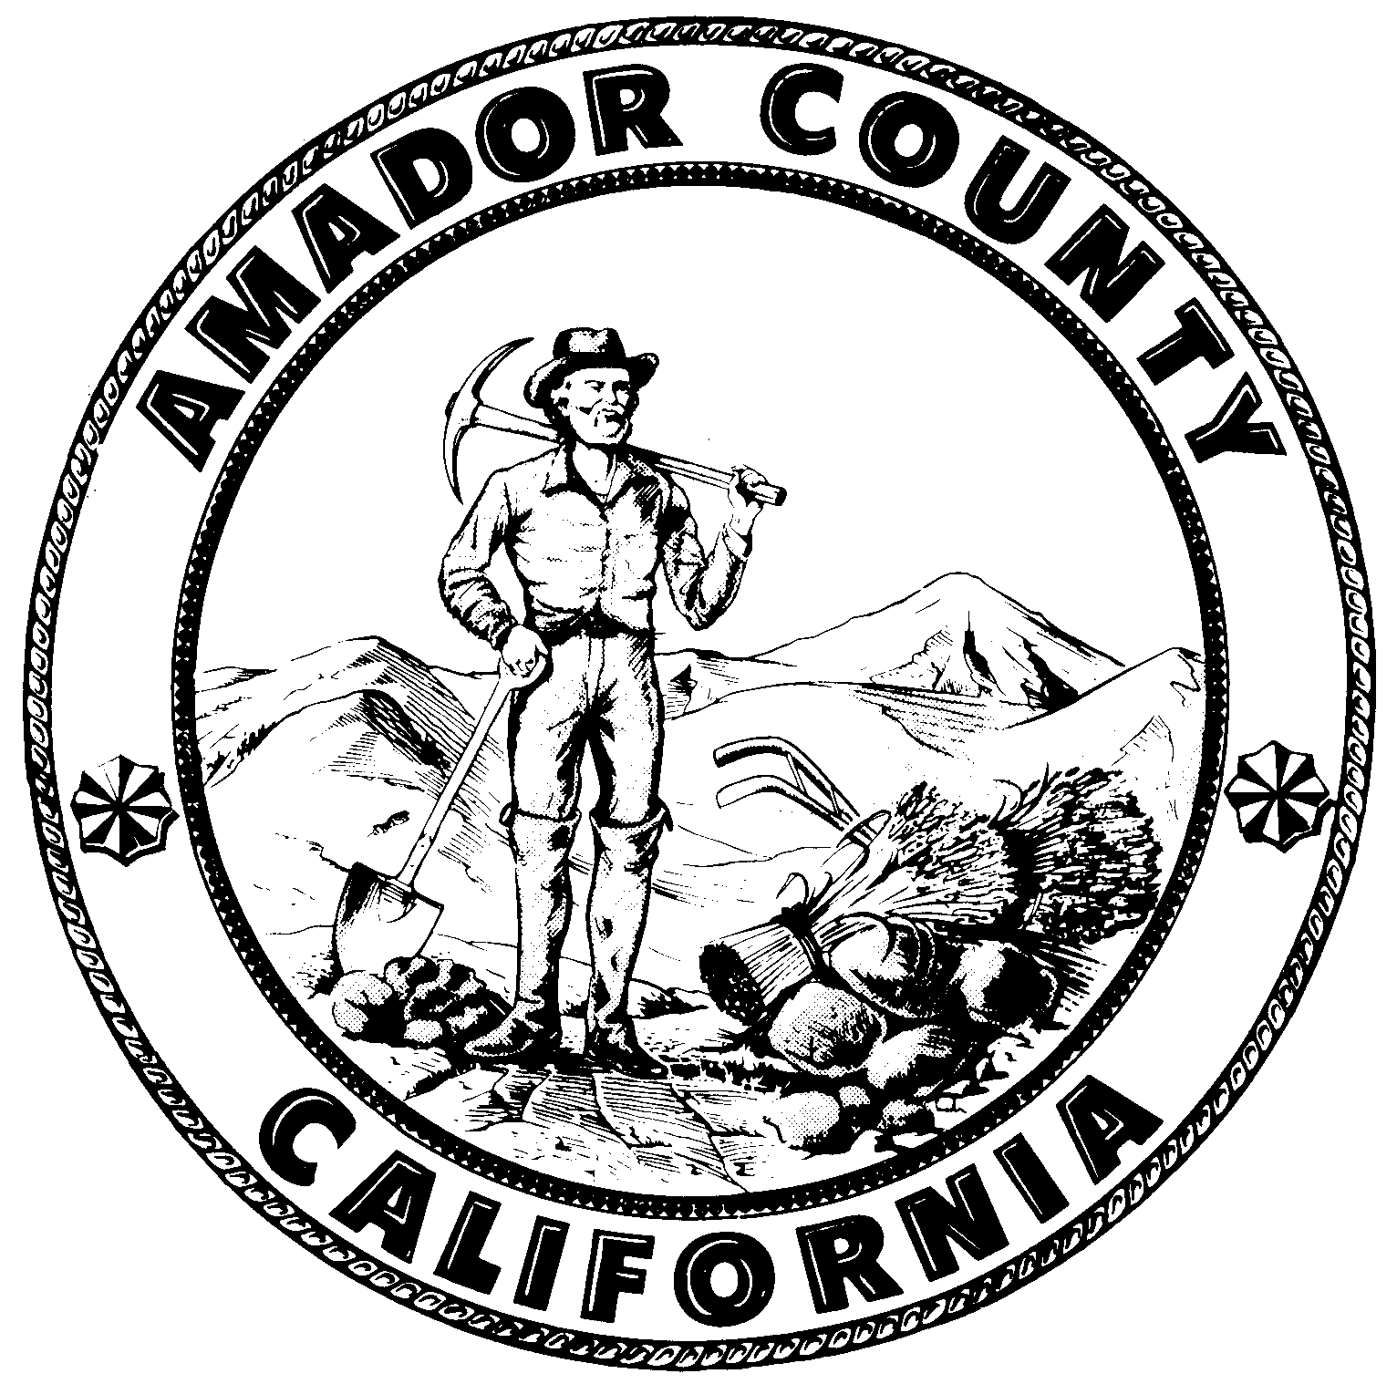
810 Court Street
Jackson, CA 95642
Phone: (209) 223-6439
Fax: (209) 223-6228
Email: ACEH@amadorgov.org

Cottage Food Registration Form

CFO Business Name: |  |  |  | Date:
CFO Physical Address: |  | CFO City: |  |  | CFO ZIP:
Owner Name: | Owner Phone: |  | Owner Cell:
Mailing Address (if different): |  | Mailing City: |  |  | Mailing ZIP:
Email Address:

Website:

- Categories:

 | “Class A” (Direct Sales Only) |  | “Class B” ( Direct & Indirect Sales)

- Prohibited Items: Initial if you agree to abide by the following: ________
If your Cottage Food operation will exceed $75 thousand(Class A) or $150 thousand (Class B) gross annual sales or you plan to manufacture a food NOT on the approved Cottage Food List (see list below, item 5), then you are not eligible to register as a Cottage Food Operation. You must obtain a Processed Food Registration from the Department of Health Services, Food and Drug Branch in accordance with California Health and Safety Code Section 110460. Visit https://www.cdph.ca.gov/Programs/CEH/DFDCS/Pages/FDBPrograms/FoodSafetyProgram/ProcessedFoodRegistration.aspx for more information.


Foods containing cream, custard, or meat fillings are potentially hazardous and are NOT ALLOWED. Only foods that are defined as “non-potentially hazardous” are approved for preparation by a Cottage Food Operation (CFO). These are food items that do not require refrigeration to keep them safe from bacterial growth that could be a cause of food-borne illness.

- Zoning:

Applicable zoning requirements have been met and/or a business license has been obtained and is attached.

- “Class A” Self Certification Checklist:

Checklist completed (“Class A” CFOs Only)

- Approved Cottage Food List:

- BAKED GOODS WITHOUT CREAM, CUSTARD, OR MEAT FILLINGS.
Examples: Bagels * Baklava * Biscuits * Bread * Brownies * Buns * Cake * Churros * Coconut Macaroons * Cookies * Crackers * Cupcakes * Donuts (fried or baked) * Empanadas (fruit only) * Flatbreads * Fruit, Nut, or Seed Bars * Macarons (with approved Buttercream) * Muffins * Pastries * Pies (fruit only) * Pizelles * Quick Breads * Samosas (fruit only) * Tamales (fruit only) * Tarts * Tortillas * Torts * Waffles (fried or baked) * Waffle Cones

- CANDY AND CONFECTIONS.
Examples: Brittles * Candied Apples * Candied Popcorn (balls, carmel, chocolate) * Carmels * Cotton Candy * Chocolate-Covered Non-Perishables including: marshmallows, nuts, candy, dried fruit, potato chips, or any combination * Edible Dessert Sprinkles including: sanding and crystalized sugars, non-pareils, confetti, sequins, dragees, sugar-shapes, sugar-strands (jimmies), comfits, minichocolates, and pralines* Freeze-Died Candies * Fudge * Ground Chocolate * Hard Candy * Marshmallow Bars * Marshmallows that do not contain eggs * Popcorn Balls * Salted Caramels * Spiced Sugars * Toffee

- VANILLA EXTRACT CONTAINING AT LEAST 70 PROOF VODKA OR BOURBON

- DRIED, DEHYDRATED AND FREEZE-DRIED FOODS.
Examples: Baking Mixes * Bean Soup Mixes *Cereals * Coffee (roasted or freeze-dried) * Fruit * Fruit Powders * Fruit Roll-Ups * Grain Mixes * Granola * Ground Chocolate * Herbs and Herb Blends * Hot Chocolate Mix * Mole Paste * Pasta * Popcorn * Potato Chips * Seasoning Salt * Spice Mix or Rubs * Tea * Trail Mixes * Vegetables * Vegetable Chips * Vegetable Soup Mixes
- FROSTINGS, ICINGS, FONDANTS, AND GUM PASTES THAT DO NOT CONTAIN EGGS†, CREAM, OR CREAM CHEESE.
Examples; Buttercream - traditional, vegan, and chocolate * Fondant - regular and chocolate * Flat Icing * Gum Paste with pasteurized eggs * Edible Images * Sugar Glazes * Vegan Gum Paste †Frostings and Icings made with meringue powder, powder eggs, or pasteurized eggs are allowed

- HONEY AND SORGHUM SYRUPS

- FRUIT BUTTERS, JAMS, JELLIES, AND PRESERVES THAT COMPLY WITH Part 150 of Title 21 of the Code of Federal Regulations (Please see link at the bottom of this section for more details)

- NUTS, NUT MIXES, AND NUT BUTTERS

- PROTEIN POWDER SHAKE MIXES MADE FROM MANUFACTURED INGREDIENTS.

- VINEGARS AND MUSTARDS.
Examples: Mustards without eggs * Vinegars * Fruit-Infused Vinegars using only high acid fruit such as: apple, blackberry, blueberry, cherry, crabapple, cranberry, grape, gooseberry, grapefruit, huckleberry, kumquat, lemon, lime, loganberry, nectarine, orange, peach, plum, pineapple, pomegranate, quince, raspberry, strawberry, tomatillo, youngberry, Fruit Butters, jams, jellies, and preserves: Cottage Food Operations that wish to produce fruit butters, jams, jellies, and preserves must meet the legally established standards set forth in 21 CFR Part 150. The purpose of the regulation is to maintain the integrity of the food and ensure consumers know what product they are receiving. The regulation establishes labeling requirements and limits the ingredients that may be used when producing these foods. Cottage Food Operations cannot use any ingredient not listed in 21 CFR Part 150, including low-acid ingredients such as peppers to create pepper jelly. Use of a low-acid ingredient may cause the formation of the botulism toxin in the product if proper controls are not used.
**These items must comply with standards described in Part 150 of Title 21 of the Code of Federal Regulations http://www.accessdata.fda.gov/scripts/cdrh/cfdocs/cfCFR/CFRSearch.cfm?CFRPart=150

Please list ALL foods items you will be preparing and/or selling.

- Product Labeling: Initial if you agree to abide by the following: ________

For a detailed description, see the CDPH document “Labeling Requirements for Cottage Food Products.” All cottage food products must be properly labeled in compliance with the Federal, Food, Drug, and Cosmetic Act (21 U.S.C. Sec. 343 et seq.) The label must include:

- The words “Made in a Home Kitchen” in 12-point type
- The name commonly used to describe the food product
- The name city, state and zip code of the cottage food operation which produced the cottage food product. If the firm is not listed in the current telephone directory then a street address must also be declared. (A contact phone number or email address is optional but may be helpful for consumers to contact your business.
- The registration or permit number of the cottage food operation which produced the cottage food product and the name of the county where the permit was issued.
- The ingredients of the food product, in descending order of predominance by weight, if the product contains two or more ingredients.
- The net quantity (count, weight, or volume) of the food product. It must be stated in both English (pound) units and metric units (grams).
- A declaration on the label in plain language if the food contains any of the eight major food allergens such as milk, eggs, fish, shellfish, tree nuts, wheat, peanuts, and soybeans. There are two approved methods prescribed by federal law for declaring the food sources of allergens in packaged foods: 1) in a separate summary statement immediately following or adjacent to the ingredient list, or 2) within the ingredient list.
- If the label makes approved nutrient content claims or health claims, the label must contain a “Nutrition Facts” statement on the information panel.
  - The use of the following eleven terms are considered nutrient content claims (nutritional value of a food): free, low, reduced, fewer, high, less, more, lean, extra lean, good source, and light. Specific requirements have been established for the use of these terms. Please refer to the Cottage Food Labeling Guideline for more details.
  - A health claim is a statement or message on the label that describes the relationship between a food component and a disease or health-related condition (e.g., sodium and hypertension, calcium and osteoporosis). Please refer to the Cottage Food Labeling Guideline for more details.
- Labels must be legible and in English (accurately translated information in another language may accompany it).
- Labels, wrappers, inks, adhesives, paper, and packaging materials that come into contact with the cottage food product by touching the product or penetrating the packaging must be food-grade (safe for food contact) and not contaminate the food.
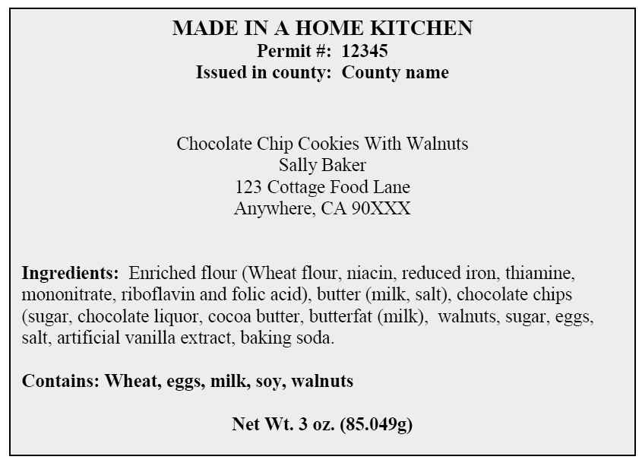

EXAMPLE:

Note: For the “Issued in County” – Identify the jurisdiction (city/county) where you are obtaining approval.
A copy of the label for each food product has been submitted to this Department for review and approval. A sample label for each food product is attached.

- Water Source:

Please identify the water source to be used in Cottage Food Facility (Check one box)

Municipal Water System or Community Services District. Name:______________________

Private Water Supply. Describe (well, spring, and other):____________________________
Private source must be a properly constructed well or spring

Private Water Supply – Attach the following initial water quality monitoring results
(Required ongoing monitoring frequencies shown in parentheses)
Bacteriological Test (total coliform / E.coli)
Nitrate as NO3
Nitrite as N
Nitrate + Nitrite (sum as N)
All samples must be taken to a certified laboratory.
Both class + Class B cottage food operation shall submit annual bacteriological samples.
*See Attached* Potable Water fact sheet containing information on what to do in the event of reported contamination and avoiding introducing contamination while collecting a sample.

- Disposal of Waste:
Please check what type of treatment is used to dispose of waste

 | Public Sewer Service |  |  | Private Septic System

In the event of septic system failure or plumbing problem, you are required to notify
Amador County Environmental Health Department immediately.

- Food Processor Course: Initial if you agree to abide by the following: ________

Within 3 months of being approved to operate by the Environmental Health Department, please provide proof of the completion of the California Department of Public Health (CDPH) food processor course OR obtain a generic food handlers card*. Proof of completion may be emailed to aceh@amadorgov.org or faxed to our Department at (209) 223-6228.
* See CDPH Website for more information: http://www.cdph.ca.gov/programs/Pages/fdbCottageFood.aspx

Employee: Initial if you agree to abide by the following: ________

I understand that I may not have more than one full-time equivalent cottage food employee, not including a family member or household member of the cottage food operator, working within the registered or permitted area of a private home where the cottage food operator resides and where cottage food products are prepared or packaged for direct, indirect, or direct and indirect sale to consumers.

- Gross Annual Sales: Initial if you agree to abide by the following: ________

I understand that I will lose my CFO status and will need to become permitted in a commercial facility if my CFO business exceeds $75,000 (Class A) or $150,000 (Class B) gross annual sales figures for any calendar year.

- Delivery Limitations: Initial if you agree to abide by the following: ______

I understand that I may accept orders and payments via the internet, mail or phone. However, all “Class A” & “Class B” CFO products must be delivered directly (in person) to the customer. The CFO products may not be delivered via US Mail, UPS, FedEx or using any other indirect delivery method as this is regulated/subject to CDPH registration and state and federal requirements.

- Temporary Events: Initial if you agree to abide by the following: _____

A temporary food facility is a food facility that operates only as part of approved community events or swap meets at a fixed location not to exceed the duration of the community events or swap meets. Community events are events open to the public which are of civic, political, public, or educational nature, including state and county fairs, city festivals, circuses, and other public gathering events which are deemed compliant by oversight agencies. CFOs wishing to participate in such events shall obtain a temporary food facility permit, which currently costs $112, and remains valid until the end of the calendar year provided the menu, personnel and equipment remain unchanged. Please ask the Amador County Environmental Health Department for a Temporary Food Facility Operator’s Packet.

- Owner’s Statement:

I, , agree to grant access to the local health department to conduct an inspection of my cottage food operation (mark one):

 | “Class A”: In the event of a consumer complaint or reported food-borne illness |  |  | “Class B”: For regular annual facility inspections and in the event of a consumer complaint or food-borne illness

I, , agree to notify Amador County Environmental Health Department prior to modifying my food list, type of operation, and/or method of selling, distributing, or otherwise providing my CFO products to the consumer or retailers, regardless of whether the product is sold, consigned, or given away.

Owner’s Signature |  | Print Name |  | Date

AMADOR COUNTY ENVIRONMENTAL HEALTH
810 Court Street
Jackson, CA 95642
Phone: (209) 223-6439
Fax: (209) 223-6228
Email: ACEH@amadorgov.org

COTTAGE FOOD OPERATIONS (CFOs – Class A)
SELF CERTIFICATION CHECKLIST

The following requirements are outlined in the Cottage Food Operations (CFO) regulations and are provided as minimum standards of health and safety for the preparation of approved cottage foods in the home.

CFO Business Name: |  | CFO Owner Name:
CFO Physical Address: |  |  | CFO City: |  | CFO ZIP:
Phone: | FA |  |  | PR |  | PE
Above bold boxes for official use only.
Facility Requirements: |  | Yes | No
- The CFO is located in a private dwelling where the CFO operator currently resides
- All CFO food preparation will take place in the private kitchen within that home.
- Additional storage used for the CFO will be within the home.
  - If YES, is the room used exclusively for storage?
  - Specify the room(s) that will be used for storage?
- Sleeping quarters are excluded from areas used for CFO food preparation or storage.

Zoning Requirements: | Yes | No
- I have complied with the applicable zoning requirements for the CFO.
- I have attached documentation from the Planning office (new applicants only)

Employee and Training Requirements: |  | Yes |  | No
- Have all persons preparing or packaging CFO products completed the CDPH food processor course?
  - If YES, copies of certificates are attached.
  - If NO, complete course within 3 months of CFO registration.
- The CFO has no more than 1 full-time equivalent employee? (Immediate family or household members are not included.)
Sanitation Requirements: |  |  | Yes |  | No
- Kitchen equipment and utensils used to produce CFO products are clean and maintained in a good state of repair.

- All food contact surfaces, equipment, and utensils used for the preparation, packaging, or handling of any CFO products shall be washed, rinsed, and sanitized before each use.
- All food preparation and food and equipment storage areas shall be maintained free of rodents and insects.
Food Preparation Requirements (includes packaging and handling): |  |  | Yes |  | No
- Hand washing is required immediately prior to handling foods and after engaging in any activity that contaminates the hands such as after using the toilet, coughing or sneezing, eating or smoking.
- Warm water, hand soap and clean towels are available for hand washing.
- All food ingredients used in the CFO products are from an approved source.
- Potable water shall be used for hand washing, ware washing and as an ingredient.
- Water source is a private water supply (well or spring)?
  - If PRIVATE SUPPLY, have you completed initial testing for bacteria, nitrate & nitrite?
  - If PRIVATE SUPPLY, ongoing annual sampling for coliform bacteria will be performed.
  - If PRIVATE SUPPLY, minimum 3 years of coliform bacteria results will be kept on site.
- If NO to 16, is your water source a municipal water system or community services district?
  - If YES, what is the name of the system or district?
During the preparation, packaging or handling of CFO products: |  |  | Yes |  | No
- Domestic activities such as family meal preparation, dishwashing, clothes washing or ironing, kitchen cleaning or guest entertainment are excluded from the kitchen.
- Infants, small children (younger than 12 yr. old), or pets are excluded from the kitchen.
- Smoking is excluded.
- Any person with a contagious illness shall refrain from work in the CFO.

Labeling Requirements: | Yes | No
- A copy of the label for each food product has been submitted to this Department for review and approval.
- I have attached a sample label for each food product.

Temporary Events: | Yes | No
- I intend to sell my CFO approved products at community events.
- If yes, I agree to apply for, and obtain, a temporary food facility permit for $96 before participating in such events. I understand this permit will remain valid until the end of the calendar year provided the menu, personnel and equipment remain unchanged.

By signing below you are certifying that you meet the requirements of the California Homemade Food Act, AB 1616 (Gatto), as it pertains to a “Class A” Cottage Food Operation. Prior to making any changes, I acknowledge that I must notify Amador County Environmental Health of any intended changes to the above statement.

Cottage Food Operator Checklist completed and submitted by:
Owner’s Signature |  | Print Name |  | Date

Potable Water Fact Sheet

For Cottage Food Operations Using a Private Water Supply

Cottage Food Operators monitor their private water supply at least once annually for coliform bacteria and E.coli.

** Water used during preparation of cottage food products shall meet Potable Drinking Water Standards. Test results exceeding Maximum Contaminant levels will not be permitted**

Potable Water Standard:

Test Parameter | Maximum Contaminant Level (MCL)
- Nitrate as No3 | - 45 mg/L
- Nitrate + Nitrite as Nitrogen(N) | - 10 mg/L
- Nitrite as N | - 1 mg/L
- Total Coliform | - 0 or Absent
- E.coli | - 0 or Absent

What are Coliform Bacteria?

Coliform bacteria include a large group of bacteria that occur throughout the environment. They are common in soil and surface water and may even occur on your skin. Large numbers of certain kinds of coliform bacteria can also be found in waste from humans and animals. Most types of coliform bacteria are harmless to humans, but some can cause mild illnesses and a few can lead to serious waterborne diseases. E. coli is a type of coliform bacteria. Coliform bacteria are often referred to as “indicator organisms” because they indicate the potential presence of disease-causing bacteria in water. The presence of coliform bacteria in water does not guarantee that drinking the water will cause an illness. Rather, their presence indicates that a contamination pathway exists between a source of bacteria (surface water, septic system, animal waste, etc.) and the water supply.

What are Nitrates?

Nitrate can be found in drinking water supplies. It’s presence in groundwater is can be associated with septic systems, confined animal feeding operations, or fertilizer use. Nitrate can interfere with the ability of red blood cells to carry oxygen to the tissues of the body, producing a condition called methemoglobinemia. It is of greatest concern in infants, whose immature stomach environment enables conversion of nitrate to nitrite, which is then absorbed into the blood stream. The effects of nitrite are often referred to as the "blue baby syndrome. High nitrate levels may also affect the oxygen-carrying ability of the blood of pregnant women.

How do I sample for Coliform Bacteria and Avoid Introducing Contaminants?

- Obtain sealed bottles from a certified laboratory (always have extra bottles on hand).
- Wash your hands thoroughly before handling supplies. Assemble all sampling supplies
- Select a sampling point as close as possible to the water source.
- Do not collect samples from garden hoses, dirty faucets or swing-type faucets where foreign material may contaminate the sample. Remove faucet screens, aerators or hoses.
- Open the cold water tap for about three minutes before collecting the sample.
- Disinfect the tap by thoroughly rinsing both the inside and outside of the tap with a mixture of 50 percent bleach and 50 percent tap water. Take extreme care with strong bleach (oxidizing) solutions. You may also flame-sterilize the tap unless the tap is plastic or if aerators are attached.
- Flush the tap for an additional three minutes with cold water and reduce to a gentle flow to about the width of a pencil. Do not change the water flow once you have started sampling.
- Grasp the cap along top edge and remove carefully. Do not touch the inside of the bottle or lid with your fingers. Hold the bottle in one hand and the cap in the other. Do not lay the cap down or put it in a pocket!
- Fill bottle to the 100 ml line or to a little above the black line. Do not rinse the bottle. Do not allow the bottle to overflow. Hold the bottle so water entering the bottle will not come in contact with your hands. Then place the cap on the bottle and screw it down tightly.
- Keep sample bottled chilled and deliver promptly to laboratory.

What happens if the lab reports the presence of coliform bacteria in a sample?

If the laboratory notifies you of a coliform “present” sample, please notify the Department at (209) 223-6439. Collect 2 repeat samples – one from the original sample location and one from an interior sink. If one or more repeat samples contain coliform bacteria, use the following checklist to help you locate and correct any areas where contaminants may be entering the water system:

SOURCE
- Well casing is above the floor or ground and the area around the well is clean.
- Well has a watertight seal and a U-shaped, inverted, screened vent.
- There are no openings in the well cap or casing, including around the electrical wires.
- There is no standing water around the well head.
- The well has been effectively disinfected following any well or pump repairs.
- If a spring, the collection box and the hatch or lid are watertight.
- If a spring, the overflow and drain lines are screened or protected with an angle-flap valve.
- Surface water is directed away from the spring collection area by a diversion ditch.
- The well or spring is at least 100 feet from sources of contamination, such as septic tanks, leach fields, sewers, manure, or garbage.
HYDROPNEUMATIC and BLADDER TANKS
- Tank(s) are not waterlogged and bladders are intact and functional.
- Sediment has not accumulated in the tank.

STORAGE TANKS
- There are no openings that allow entry of surface water, debris, insects, etc.
- The access hatch has an overlapping, watertight cover and a neoprene-type seal.
- Vents are clean, directed downward, and screened.
- Overflow and drain lines are protected with screens or angle-flap valves and discharge above
ground.
- There are no signs of dirt, insects, growth, sediment, or debris inside the tank.
- There are no cracks, leaks, or vegetative growth on the outside of the tank.
DISTRIBUTION SYSTEM
- There are no obvious leaks or breaks.
- The system was effectively disinfected following any construction or repair work.
- There have been no low pressure or water outage incidents.
- Non-looped, dead-end sections are regularly flushed.
- System is free of possible cross connections.
AFTER INSPECTING THE SYSTEM
- Make needed repairs and improvements.
- Disinfect and flush the system. The Department has a handout on water system disinfection.
- Resample to ensure the system is free of bacteriological contamination.

Department staff is available to assist you with troubleshooting the cause of the contamination, and advise you on what precautions you should take to protect your customers.
IMPORTANT!
If E. COLI is found in any water sample, the cottage food operations must cease until the source of the contamination is corrected, the system disinfected, and follow-up samples no longer show the presence of E. coli.

